**Study on Application of Bayesian Networks in the Domain of Chest Diseases**

Team Member: Wei Chen Chinedu Nwachukwu

**Problem statement:**

A certain causal relationship exists between smoking and chest disease. How about the number of smokers in the United States and the incidence of breast disease? Does the number reported in literatures matching the actual situation? Is it possible to obtain the occurrence rate of some sort of disease by consulting the patient and arithmetic reasoning? These situations are subject to systematic investigation.

**Goals/Objective:**

(1). To establish a meaningful Bayesian Networks (BN) model for clinical diagnosis by investigating the number of smoking and the incidence of breast diseases in the United States.

(2). To establish the BN structure diagram and provide sufficient conditional probability value for arithmetic reasoning.

**Methods**

1. Establish the Bayesian Networks (BN) model 1, according to the number of American smokers and the incidence of chest disease reported in literatures.

2. Establish a more meaningful and useful BN model 2, according to the real data by investigation.

3. Establish the BN structure diagram and provide sufficient conditional probability value.

4. Proceed the arithmetic reasoning according to Bayes formula and theorem

**Environment of Experiment: plan**

Literature review and the BN model 1(Lab. Wei Chen)

Actual situation survey and the BN model 2(Hospital. Chinedu Nwachukwu)

Other works (Lab. Wei Chen and Chinedu Nwachukwu)

**Expected Outcome and/or Contribution + others ?**

1. Establish a more meaningful and useful BN model (such as the following figure) and serve for the clinical diagnosis,

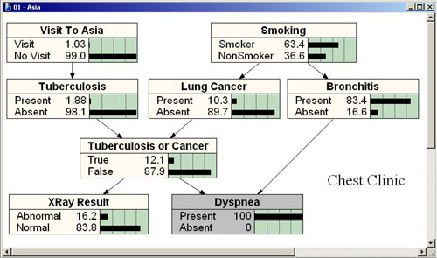

2. By using the Bayes formula and theorem to serve for the clinical diagnostic inference.